
Applied Science Private University
Faculty of Information Technology

Graduation Project (1) Report

SentriX

Prepared by:
Jasem Jaber 202211069
Mohanad Hamdan 202210554
Faissal Alassali 202210573

Supervised by:
Dr.Marwan Alakhras

Jan 2026

Copyright © 2025-2026 Applied Science Private University. All rights are reserved
Contents
Abstract 1
Chapter 1: Introduction 2
Overview 2
1.1 Description of the current situation and opportunity 3
1.2 Related work 5
1.3 Problem statement (limitation of current systems) 7
1.4 Problem solution 8
1.5 Project objectives 10
1.6 Technology and tools used 11
1.7 Project plan for GP2 (Gantt chart, PERT chart) 13
Chapter 2: Requirements and Analysis 15
2.1 Software Process Model 15
2.2 System scope with explanation 16
2.3 List of Functional Requirements and Non-Functional Requirements 17
2.4 Use Case Diagram with Use Cases descriptions 22
Chapter 3: Design 31
Chapter 3: 31
3.1 Conceptual Class Diagram 31
3.2 Provisional Database ER Diagram 32
Bibliography 33

Abstract
This project presents an intelligent, AI-driven Security Operations Centers (SOC) platform designed to enhance the accuracy, speed, and efficiency of cybersecurity incident analysis. The system integrates SIEM [1] , SOAR[2] , and VirusTotal [3] into a unified backend that collects, correlates, and enriches security alerts from multiple sources. Using Retrieval-Augmented Generation (RAG) [4] , the platform retrieves real threat intelligence and provides the AI model with relevant context, enabling it to generate precise incident descriptions, indicators of compromise (IOCs) [5] , and effective response recommendations in real time. In addition to a modern interactive dashboard that allows users to engage with the system as a virtual SOC analyst, supporting faster investigations, reducing analyst workload, and improving overall incident response within an organization.

Chapter 1: Introduction

Overview
Modern Security Operations Centers (SOCs) face significant operational challenges due to the rapid growth of security events generated by heterogeneous infrastructures, including endpoints, servers, networks, and cloud environments. Traditional SOC architectures rely on multiple independent systems, such as Security Information and Event Management (SIEM) systems for log collection, Security Orchestration, Automation, and Response (SOAR) platforms for incident handling, and external threat intelligence platforms for enrichment, which often operate in isolation. This fragmented approach forces analysts to manually correlate alerts, resulting in alert fatigue, delayed incident response, and inefficient use of security resources.
This project proposes SentriX, an integrated SOC platform that unifies security event monitoring, incident management, and automated analysis within a single architecture. SentriX leverages SIEM-based log collection, SOAR-driven case management and orchestration, and external threat intelligence enrichment to provide centralized and structured incident handling. In addition, the system incorporates a Retrieval-Augmented Generation (RAG) framework that grounds AI-generated analysis in real organizational security data, enabling context-aware incident summaries, indicator extraction, and response recommendations.
By automating alert correlation and enrichment while supporting human-in-the-loop decision-making, SentriX aims to reduce investigation time, and improve the overall effectiveness of SOC operations.

Description of the current situation and opportunity
Current Situation:
Nowadays, organizations across all sectors -finance, healthcare, telecommunications, and even education- have become heavily dependent on digital infrastructures. Where, cloud services, remote work environments, online transactions, and data-driven operations. are now the backbone of those modern business sectors.
But while this dependency improved accessibility and efficiency, it also opened the door to a rapidly growing wave of cyber threats. Security Operations Centers (SOCs) are now flooded with enormous volumes of alerts generated every second from firewalls, servers, endpoints, and networks.
The result: Security analysts are buried under alert fatigue, forced to manually sort through thousands of notifications just to identify which ones actually matter.
And the tools they rely on often create even more challenges: for instance SIEM platforms are used collect logs, SOAR automates responses, and threat intelligence tools enrich information, …but they operate in silos.
The analyst has to switch between dashboards, correlate data manually, and depend heavily on personal expertise and experience, which leads to:
- slower incident response
- higher risk of missed threats
- increased human error
- analyst burnout
Meanwhile, attackers aren’t standing still. Modern cybercriminals leverage automation, AI-powered malware, phishing campaigns tailored to individuals, and advanced evasion techniques that traditional tools struggle to detect.

In simple terms:
Organizations today are caught in an uneven race, attackers are getting faster and smarter, while defenders are still fighting with slow and disconnected tools.
Opportunity:
This critical gap in current cybersecurity operations presents a major opportunity to redefine how Security Operations Centers (SOCs) function. As organizations face an overwhelming surge in security alerts and increasingly sophisticated cyber threats, the limitations of traditional, manual SOC workflows have become impossible to ignore. Analysts are required to work across disconnected SIEM, SOAR, and threat intelligence tools, manually correlating data, prioritizing incidents, and responding under constant pressure—an approach that is both inefficient and unsustainable.
This growing pressure creates a clear opportunity to build a unified, AI-driven SOC platform that goes beyond conventional security solutions[6] . By integrating SIEM, SOAR, and threat intelligence into a single intelligent ecosystem, such a platform can automatically collect and correlate alerts, enrich them with real-time contextual threat data, prioritize incidents based on actual risk, and generate actionable responses instantly. Leveraging advanced AI techniques such as Retrieval-Augmented Generation (RAG), the system can act as a “virtual SOC analyst,” providing meaningful insights, accurate incident analysis, and response recommendations with minimal human intervention.
Instead of security teams juggling over multiple dashboards and fragmented tools, the idea of adding an AI-powered SOC platform may simplify the entire incident response lifecycle by enabling faster detection, automated analysis, reduce analyst workload, and improve accuracy. It allows organizations to shift from a reactive defense model to a proactive and intelligence-driven approach to threat management.
The value of this opportunity extends beyond large enterprises. Government agencies, Universities, healthcare institutions, and startups are treated alike, they can benefit from smarter, scalable, and more efficient security operations. Ultimately, leveraging AI to create an integrated and intelligent SOC platform turns cybersecurity from a constant operational struggle into a strategic advantage capable of keeping pace with modern threats.

Related work
Several existing solutions address different components of the Security Operations Center (SOC) workflow; however, most of them operate in isolation and do not provide a fully integrated and intelligent incident handling process.
Security Information and Event Management (SIEM) platforms are designed to collect, aggregate, and analyze log data in real time from various sources within an organization. Their primary strength lies in their ability to correlate events across multiple network layers and systems to detect potential security incidents. Well-known SIEM solutions include Splunk, Elastic SIEM, IBM QRadar, and Wazuh. Despite their effectiveness in log management and alert generation, traditional SIEM systems are largely passive. They notify analysts of suspicious activities but do not autonomously investigate alerts or provide actionable remediation steps. This heavy reliance on manual triage often results in alert fatigue, where genuine threats are obscured by a large volume of false positives, ultimately delaying incident response.
Security Orchestration, Automation, and Response (SOAR) systems were introduced to address some of these challenges by automating and coordinating incident response workflows. SOAR platforms integrate multiple security tools and execute predefined playbooks to perform tasks such as alert enrichment, investigation, and containment. Examples of widely used SOAR solutions include Cortex XSOAR, Splunk SOAR, IBM Resilient, Shuffle SOAR, and TheHive with Cortex. While these systems significantly improve response speed and operational consistency, they still rely heavily on static, rule-based workflows. As a result, they lack adaptive intelligence and continue to depend on human analysts for complex reasoning, contextual understanding, and decision-making in sophisticated or novel attack scenarios.
AI-driven security assistants, such as Microsoft Security Copilot, have emerged to support analysts by generating summaries, explanations, and recommendations using large language models. Although these tools enhance usability and reduce analysis time, they suffer from a key limitation: limited deep integration with an organization’s internal security data and tools. Without direct access to real-time logs, alerts, and historical incident data, their outputs tend to be generic and lack the contextual accuracy required for precise threat investigation and response.
Threat intelligence services, including VirusTotal and similar platforms, play a vital role in enriching security events with external context by analyzing file hashes, URLs, IP addresses, and domains. These services help identify known malicious indicators and provide valuable reputation data. However, they primarily function as reference and enrichment tools rather than full analytical systems. They do not correlate indicators across incidents or generate comprehensive incident narratives, leaving analysts responsible for manually linking this intelligence to specific alerts and organizational contexts.

In summary, existing SIEM, SOAR, AI assistants, and threat intelligence solutions each address specific aspects of the SOC workflow. However, their fragmented nature and lack of deep contextual intelligence highlight the need for a unified, AI-driven SOC platform capable of integrating these tools and delivering end-to-end, context-aware incident analysis and response.

Problem statement (limitation of current systems)
The escalating complexity of cyber threats has exposed critical vulnerabilities in traditional SOCs. Despite heavy investment in security stacks, modern SOC infrastructures are increasingly struggling to keep pace with the evolving threat landscape. This operational strain is primarily driven by several systemic bottlenecks:
1. Siloed Architecture & Manual Correlation:
the Current SOC environments suffer from will definitely lead to the "Islands of Data" problem [7]

2. Alert Fatigue & Unstructured Data Deluge
Organizations are facing an explosion in security data volume, leading to a flood of unprioritized alerts. This "digital noise" causes analysts to overlook approximately 25% of alerts that could represent actual breaches. [8]
3. Extended Dwell Time & Dependency on Human Expertise
Manual incident investigation is inherently slow and typically requires Tier 3 experts to handle complex threats. Over-reliance on human intuition increases the probability of critical errors and delays. [9]
4. Context-Awareness Gap in AI
Current AI assistants, despite their processing power, often lack access to "live organizational data." Without Retrieval-Augmented Generation (RAG), AI outputs tend to be generic "hallucinations" that lack the precision required for sensitive security decision-making. [10]

5. Static Response Workflows (Automation Rigidity)
Most current SOAR systems rely on Static Playbooks. While attackers rapidly evolve their Tactics, Techniques, and Procedures (TTPs), automated responses remain rigid and lack the adaptability to pivot against new variables.[11]

Problem solution
The proposed solution, SentriX, addresses the complex limitations of traditional Security Operations Centers by providing an intelligent, unified defense platform. By integrating industry-leading open-source tools with advanced Generative AI, SentriX transforms security operations through the following core pillars:

1. Unified Ecosystem & Seamless Integration
- SentriX eliminates the issue of "isolated silos" by integrating SIEM (via Wazuh) for log collection with SOAR (via TheHive and Cortex) for response orchestration.
- This integration removes the need for manual correlation, allowing security data to flow automatically from detection to containment, significantly reducing the Mean Time to Respond (MTTR).
- By unifying SIEM, SOAR, and threat intelligence into a single ecosystem, the platform provides a holistic view of the organization's security posture.

2. Context-Aware Analysis via RAG (The AI Engine)
- The core innovation of SentriX lies in its use of Retrieval-Augmented Generation (RAG).
- Unlike generic AI assistants, the RAG-based AI retrieves real-time data from the organization’s internal logs and enriches it with external intelligence from VirusTotal.
- This allows the system to generate precise incident descriptions and Indicators of Compromise (IOCs) while ensuring that AI responses are grounded in actual organizational context, effectively eliminating "AI hallucinations".

3. Adaptive Automation & Enhanced Decision Making
- The system automates the classification and correlation of alerts to combat alert fatigue, ensuring that analysts focus on high-priority threats.
- Instead of relying solely on static, predefined playbooks, the AI engine provides dynamic response recommendations tailored to the specific nuances of each incident.
- This shift reduces the manual workload and minimizes the risk of human error during complex investigations.

5. The Virtual SOC Analyst Interface
- SentriX features a modern, interactive Frontend dashboard that acts as a Virtual SOC Analyst.
- Security analysts can interact with the system using natural language to receive instant summaries, complete incident reports, and actionable remediation steps.
- This interface democratizes advanced cybersecurity by enabling less experienced teams to perform high-level threat analysis with expert-level guidance.

Value Proposition Summary
- Accuracy: Delivers context-aware insights that go beyond dry, static alerts.
- Efficiency: Automates the end-to-end incident response lifecycle.
- Cost-Effectiveness: Provides enterprise-grade security capabilities by leveraging a sophisticated, open-source-based architecture

Project objectives
The primary objective of SentriX is to develop an intelligent, integrated security platform that enhances the efficiency of Security Operations Centers (SOC) by bridging the gap between detection, analysis, and response. The specific objectives are:

- Architectural Consolidation & Unified Integration: To engineer a cohesive backend that seamlessly integrates SIEM (Wazuh), SOAR (TheHive/Cortex), and external Threat Intelligence (VirusTotal) into a single operational hub. This objective focuses on eliminating "data silos" and ensuring a frictionless flow of security telemetry across the entire detection-to-response pipeline.
- Deployment of Context-Aware AI (RAG Framework): To implement a Retrieval-Augmented Generation (RAG) architecture that utilizes ChromaDB and LangChain to ground Large Language Models (LLMs) in real-time organizational logs. This ensures that incident analysis is not merely generic, but is precisely tailored to the specific context of the organization’s digital infrastructure.

- Interactive Virtual SOC Analyst Interface: To deliver a sophisticated, user-centric dashboard that functions as a Virtual SOC Analyst. This interface will allow users to engage with the AI engine through natural language to retrieve instant incident summaries, forensic details, and response recommendations, effectively bridging the cybersecurity skills gap.
- Strategic Optimization of Security Costs: To demonstrate that an enterprise-grade, AI-driven security platform can be built using an Open-Source architecture. This objective proves the scalability and cost-effectiveness of SentriX, making advanced cyber defense accessible to institutions that cannot afford the prohibitive costs of proprietary platforms like Splunk or QRadar.

Technology and tools used

Technology | Why do we use it? (Purpose) | How do we use it? (Mechanism) | Where does it fit? (Architecture Layer) | Reference Link
Wazuh (SIEM) | To collect system logs from devices, detect attacks, and generate security alerts. | Agents are installed on endpoints to send data to the Wazuh server, which analyzes it against specific rules. | Detection Layer: It is the primary source of raw data and alerts. | Wazuh [12]
TheHive + Cortex (SOAR) | TheHive:For Case Management (tracking incidents).  Cortex:Orchestration (automating analysis tools). | TheHive converts alerts into "cases," while Cortex automatically runs "Analyzers" on observables (like IPs or URLs). | Incident Management Layer: The operational hub where analysts manage work. | TheHive [13]  Cortex (SOAR)[14]
VirusTotal (Threat Intel) | To check the reputation of files, URLs, and IPs (Enrichment), determining if they are malicious. | We query its API to scan hashes or IPs against global antivirus engines and retrieve reports. | Enrichment Layer: Invoked by Cortex or the Backend to gather external intelligence. | VirusTotal API
ChromaDB + LangChain + OpenAI (RAG + AI) | To provide intelligent, context-aware analysis and dynamic response recommendations (overcoming static playbooks). | ChromaDB: Stores context as vectors.  LangChain: Connects components.  OpenAI: Generates the final reasoning and response. | AI Engine: The "brain" that analyzes the alert and decides on the action. | LangChain [15]  Chroma[16]
FastAPI (Backend) | To connect the Frontend with the AI and SIEM components with high performance, leveraging native Python support for AI tools. | We create API  endpoints that receive user requests, process them via the AI engine, and return results. | Server-side / Backend: The backbone that integrates all systems. | FastAPI Docs[17]
HTML + CSS + JS (Frontend) | To build the User Interface (Dashboard) where security analysts view alerts and AI insights. | We design web pages that visualize the data and decisions fetched from the FastAPI backend. | Client-side / Frontend: The visual interface for the end-user. | MDN Web Docs[18]

Project plan for GP2 (Gantt chart, PERT chart)

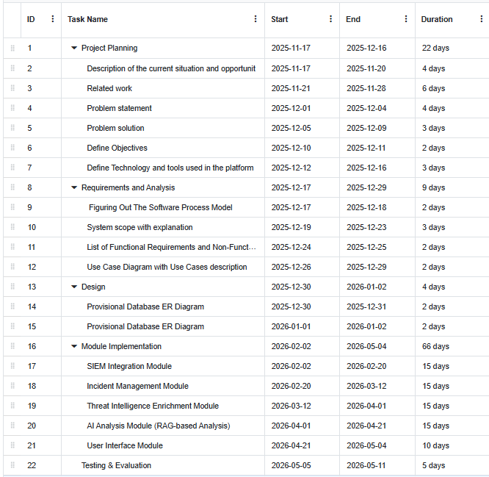
Figure 1: (Gantt Chart illustrating the project phases and task durations)

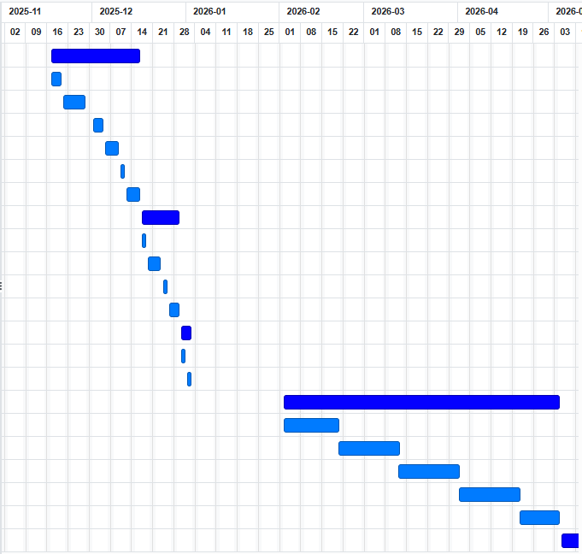

Figure 2: (Visual timeline of project phases and milestones)

Chapter 2: Requirements and Analysis

Software Process Model
In this project, an iterative software process model was adopted to guide the development of the system. The iterative model organizes software development into a series of repeated cycles (iterations), where each iteration focuses on designing, implementing, and testing a specific part of the system. At the end of each iteration, the developed components are evaluated and refined based on feedback before proceeding to the next iteration.
This model was selected due to its flexibility and suitability for complex systems that require continuous enhancement and integration, such as cybersecurity and artificial intelligence–based applications. By adopting an iterative approach, the system can gradually evolve while reducing risks at early stages of development. Furthermore, this model supports the incremental development of key system components, including log collection, incident analysis, artificial intelligence integration, and automated response mechanisms, ensuring better control over development progress and continuous refinement throughout the software lifecycle.
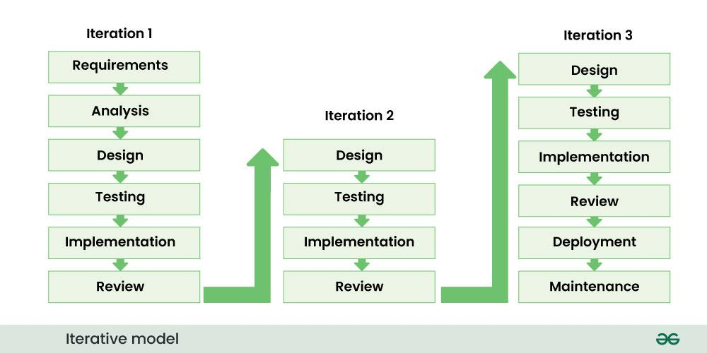
Figure 3: ( The Iterative software development lifecycle phases)

System scope with explanation
This project aims to design and develop an intelligent system called SentriX to support Security Operations Center (SOC) activities and enhance the efficiency of security incident analysis and decision-making. The system focuses on addressing key challenges faced by SOC analysts, such as the high volume of security alerts, the diversity of data sources, and the need for fast and accurate incident analysis.
The scope of the system includes collecting security alerts from Security Information and Event Management (SIEM) systems, where these alerts are organized, correlated, and transformed into manageable security incidents. The system provides centralized incident management, enabling each incident to be tracked throughout its lifecycle, starting from detection, through analysis, and ending with the selection of an appropriate response. This approach helps reduce complexity and improves the overall visibility of the security posture for SOC analysts.
The system utilizes artificial intelligence techniques to analyze security incidents and assist SOC analysts in understanding the nature of threats, determining their severity, and correlating related events. In addition, the system leverages threat intelligence sources to enrich incidents with additional context, such as known indicators of malicious activity, which contributes to a clearer and more accurate understanding of potential threats.
Furthermore, the system recommends intelligent security response actions based on the analysis results and available context, while keeping the final decision under human control. The system also supports partial automation of selected response actions to accelerate incident handling and reduce manual effort. An interactive and user-friendly interface is provided to allow SOC analysts to monitor alerts, investigate incidents, and interact effectively with the system’s outputs.
The scope of this project is limited to supporting and assisting SOC analysts and does not aim to fully replace human expertise or rely on complete automation for decision-making. The project scope also excludes the development of SIEM or SOAR platforms from scratch, direct execution of response actions on sensitive production systems, physical security controls, and large-scale training of artificial intelligence models. The project primarily focuses on integrating existing tools and enhancing their capabilities through the use of artificial intelligence.

List of Functional Requirements and Non-Functional Requirements
Functional Requirements (FR):
FR1: User Authentication and Authorization
FR1.1: The system shall require user authentication before granting access to the SentriX platform.
FR1.2: The system shall log all user activities for auditing and compliance purposes.
FR2: Security Event Collection and Monitoring (SIEM – Wazuh)
FR2.1: The system shall collect security logs and events from servers, endpoints, and network devices using Wazuh SIEM agents.
FR2.2: The system shall continuously monitor network traffic, system logs, and authentication events in real time.
FR2.3: The system shall normalize, parse, and structure collected logs within the Wazuh Manager to enable accurate correlation and analysis.
FR3: Alert Generation and Classification
FR3.1: The system shall generate security alerts based on predefined detection rules and threat signatures provided by Wazuh.
FR3.2: The system shall classify alerts according to severity levels:
- Critical
- High
- Medium
- Low
FR3.3: The system shall detect common cyberattack patterns, including malware activity, brute-force attacks, and unauthorized access attempts.

FR4: Incident Case Management (SOAR – TheHive)
FR4.1: The system shall automatically create incident cases in TheHive when high-severity security alerts are received.
FR4.2: The system shall allow SOC analysts to view, update, and close incident cases through the case management interface.
FR4.3: The system shall track the incident lifecycle using the following states:
- New
- In Progress
- Resolved
- Closed
FR4.4: The system shall maintain a complete audit trail of all actions performed on each incident case.

FR5: Threat Intelligence Enrichment (VirusTotal)
FR5.1: The system shall integrate with the VirusTotal API to enrich Indicators of Compromise (IOCs).
FR5.2: The system shall automatically query VirusTotal for file hashes, IP addresses, URLs, and domain names associated with security incidents.
FR5.3: The system shall display threat intelligence enrichment results alongside the original alert and incident data.

FR6: Security Orchestration and Automation (SOAR – Cortex)
FR6.1: The system shall execute automated security analysis tasks using Cortex analyzers integrated with TheHive.
FR6.2: The system shall support parallel execution of multiple analyzers on observables such as IP addresses, files, and URLs.
FR6.3: The system shall automate repetitive investigative tasks, including IOC scanning and IP reputation analysis, to reduce analyst workload.

FR7: AI-Powered Analysis Using Retrieval-Augmented Generation (RAG)
FR7.1: The system shall implement a Retrieval-Augmented Generation (RAG) framework using ChromaDB and LangChain.
FR7.2: The system shall store organizational security context, historical incidents, and response procedures as vector embeddings within ChromaDB.
FR7.3: The system shall use OpenAI language models to generate context-aware incident summaries and analytical descriptions grounded in real organizational data.
FR7.4: The system shall automatically extract Indicators of Compromise (IOCs) and provide actionable, context-driven response recommendations.

FR8: Interactive Web-Based Dashboard
FR8.1: The system shall provide a unified, web-based dashboard accessible through modern web browsers.
FR8.2: The system shall display real-time operational statistics, including active alerts, open incidents, and overall threat levels.
FR8.3: The system shall visualize security data using interactive charts and graphs.
FR8.4: The system shall provide advanced search and filtering capabilities for alerts and incident cases.

FR9: Virtual SOC Analyst (AI Chat Interface)
FR9.1: The system shall provide an interactive chat interface that supports natural language queries.
FR9.2: The system shall generate instant, AI-driven incident summaries upon analyst request.
FR9.3: The system shall provide step-by-step remediation and response guidance through the chat interface.

FR10: Reporting and Documentation
FR10.1: The system shall generate comprehensive incident reports including timelines, IOCs, and actions taken during response.
FR10.2: The system shall support exporting reports in multiple formats, including PDF, JSON, and CSV.
FR10.3: The system shall maintain historical records of all security incidents for auditing and analysis purposes.

Non-Functional Requirements (NFR)
NFR1: Performance
NFR1.1: Real-Time Processing, the system shall process security alerts and generate AI-driven incident summaries within timeframes that enable timely threat response and decision-making.
NFR1.2: Concurrent Load Handling, the system shall maintain responsive performance under typical operational loads, supporting multiple concurrent users and high-volume event processing without degradation.

NFR2: Scalability
NFR2.1: Infrastructure Scalability, the system shall scale horizontally to handle growing endpoints, event volumes, and data without architectural changes or performance loss.
NFR2.2: Modular Extensibility, the system shall support seamless integration of additional security tools through modular architecture and standardized interfaces.

NFR3: Reliability and Availability
NFR3.1: Fault Tolerance, the system should maintain continuous operation and data integrity during individual component failures or degraded performance.
NFR3.2: The system shall perform automated backups of critical configuration and incident data every 24 hours.

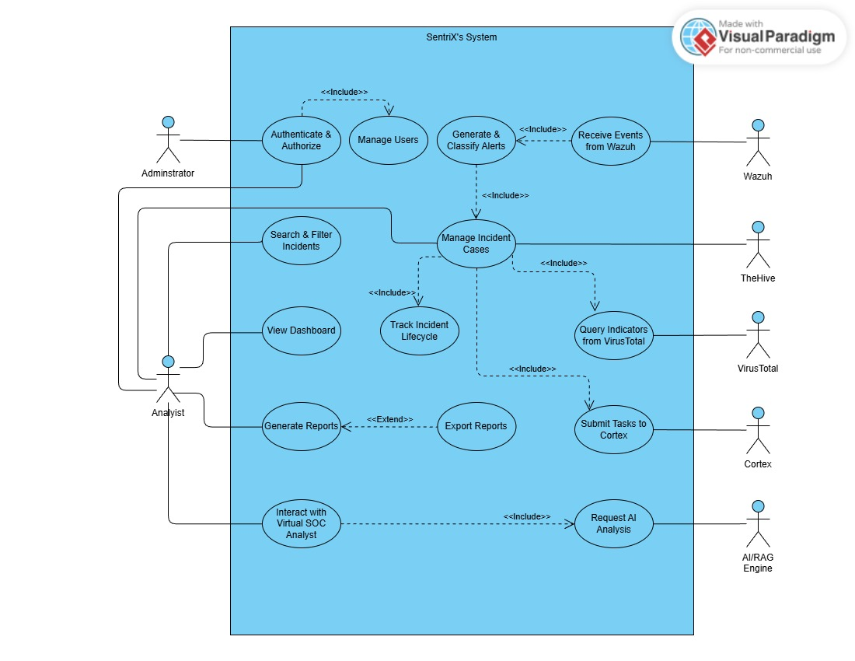
Use Case Diagram with Use Cases descriptions

Figure 4: (Use Case Diagram)

Use Cases Descriptions:

Field | Description
Use Case ID | UC-01
Use Case Name | Authenticate & Authorize
Brief Description | Users securely log in and access the SentriX system based on their roles.
Actors | Administrator, Analyst
Preconditions | User has a valid registered account.
Post-conditions | User is successfully authenticated and redirected to the dashboard.
Normal Flow | 1. The user opens the login page.
 | 2. The user enters username and password.
 | 3. The system validates the credentials.
 | 4. The system checks the assigned role.
 | 5. The user is granted access to the system.
Exceptions | • Invalid credentials → error message displayed.
 | • Disabled / locked account → access denied.
 | • Required fields are not filled → system requests completion.
Includes | –
Extends | –

Field | Description
Use Case ID | UC-02
Use Case Name | Manage Users
Brief Description | The administrator manages user accounts and permissions.
Actors | Administrator
Preconditions | Administrator is authenticated.
Post-conditions | User accounts and roles are updated in the system.
Normal Flow | 1. Administrator opens the user management interface.
 | 2. Administrator selects add, edit, delete, or disable user.
 | 3. Administrator fills in required user information.
 | 4. System validates inputs.
 | 5. System saves the changes successfully.
Exceptions | • Missing required information.
 | • Duplicate username or email.
 | • Unauthorized access by non-administrator user.
Includes | Authenticate & Authorize
Extends | –

Field | Description
Use Case ID | UC-03
Use Case Name | Receive Events from Wazuh
Brief Description | The system receives security events and logs from Wazuh SIEM.
Actors | Wazuh
Preconditions | Wazuh SIEM is running and connected.
Post-conditions | Events are stored and ready for alert generation.
Normal Flow | 1. Wazuh collects logs from endpoints and servers.
 | 2. Wazuh sends the events to SentriX.
 | 3. SentriX stores and processes the events.
Exceptions | • Network connection failure.
 | • Event format not supported.
Includes | –
Extends | –

Field | Description
Use Case ID | UC-04
Use Case Name | Generate & Classify Alerts
Brief Description | The system generates alerts from incoming events and classifies severity.
Actors | System
Preconditions | Security events have been received.
Post-conditions | Alerts are generated and categorized.
Normal Flow | 1. The system analyzes incoming events.
 | 2. Detection rules are applied.
 | 3. An alert is generated.
 | 4. Severity level is assigned.
Exceptions | • False positives generated.
 | • Misconfigured detection rules.
Includes | Receive Events from Wazuh
Extends | –

Field | Description
Use Case ID | UC-05
Use Case Name | Manage Incident Cases
Brief Description | Analysts manage security incidents as structured cases.
Actors | Analyst
Preconditions | An alert or incident already exists.
Post-conditions | Incident case is saved and updated.
Normal Flow | 1. Analyst opens incident management page.
 | 2. Analyst creates or updates a case.
 | 3. Analyst assigns case if needed.
 | 4. System stores changes.
Exceptions | • Missing required case fields.
 | • Invalid incident data.
Includes | • Track Incident Lifecycle
 | • Query Indicators from VirusTotal
 | • Submit Tasks to Cortex
Extends | –

Field | Description
Use Case ID | UC-06
Use Case Name | Track Incident Lifecycle
Brief Description | The system tracks incident status across its lifecycle.
Actors | Analyst, System
Preconditions | An incident case exists.
Post-conditions | Updated case status is stored.
Normal Flow | 1. Analyst opens case details.
 | 2. Analyst updates status (New, In-Progress, Resolved, Closed).
 | 3. System records lifecycle changes.
Exceptions | • Unauthorized status change.
 | • Invalid status transition.
Includes | Manage Incident Cases
Extends | –

Field | Description
Use Case ID | UC-07
Use Case Name | Query Indicators from VirusTotal
Brief Description | The system enriches indicators using VirusTotal reputation data.
Actors | Analyst, VirusTotal
Preconditions | IOC exists in the incident case.
Post-conditions | Threat intelligence is attached to the incident.
Normal Flow | 1. System extracts IOC (hash, URL, IP, domain).
 | 2. System sends query to VirusTotal.
 | 3. VirusTotal returns reputation information.
 | 4. System attaches results to the incident.
Exceptions | • Invalid IOC format.
 | • VirusTotal API unavailable.
Includes | Manage Incident Cases
Extends | –

Field | Description
Use Case ID | UC-08
Use Case Name | Submit Tasks to Cortex
Brief Description | System submits automated analysis jobs to Cortex.
Actors | Analyst, Cortex
Preconditions | An incident requires automated analysis.
Post-conditions | Analyzer results are added to the incident.
Normal Flow | 1. Analyst selects an automated task.
 | 2. System sends task to Cortex.
 | 3. Cortex executes analyzer.
 | 4. Results are returned.
Exceptions | • Cortex not reachable.
 | • Analyzer execution failure.
Includes | Manage Incident Cases
Extends | –

Field | Description
Use Case ID | UC-09
Use Case Name | Search & Filter Incidents
Brief Description | Analysts search and filter stored incidents.
Actors | Analyst
Preconditions | Analyst is authenticated.
Post-conditions | Matching results are displayed.
Normal Flow | 1. Analyst enters search criteria.
 | 2. System processes filters.
 | 3. Matching incident list appears.
Exceptions | • No matching results.
 | • Invalid filter values.
Includes | –
Extends | –

Field | Description
Use Case ID | UC-10
Use Case Name | View Dashboard
Brief Description | Displays overall SOC status.
Actors | Analyst, Administrator
Preconditions | User logged in.
Post-conditions | Dashboard displayed.
Normal Flow | 1. User opens dashboard page.
 | 2. System loads statistics and charts.
Exceptions | • Data temporarily unavailable.
Includes | –
Extends | –

Field | Description
Use Case ID | UC-11
Use Case Name | Generate Reports
Brief Description | System generates detailed incident reports.
Actors | Analyst
Preconditions | Incident/alert data exists.
Post-conditions | Report is generated.
Normal Flow | 1. Analyst selects incident.
 | 2. Analyst chooses generate report.
 | 3. System compiles content.
Exceptions | • Missing incident data.
Includes | –
Extends | Export Reports

Field | Description
Use Case ID | UC-12
Use Case Name | Export Reports
Brief Description | Reports are exported into external file formats.
Actors | Analyst
Preconditions | Report is generated.
Post-conditions | File is downloaded.
Normal Flow | 1. Analyst selects export format.
 | 2. System exports report.
Exceptions | • Unsupported export format.
Includes | –
Extends | –

Field | Description
Use Case ID | UC-13
Use Case Name | Interact with Virtual SOC Analyst
Brief Description | Analyst chats with an AI-based SOC assistant.
Actors | Analyst
Preconditions | Analyst is authenticated.
Post-conditions | AI response delivered.
Normal Flow | 1. Analyst writes a query.
 | 2. AI processes context.
 | 3. AI returns response.
Exceptions | • AI service unavailable.
Includes | Request AI Analysis
Extends | –

Field | Description
Use Case ID | UC-14
Use Case Name | Request AI Analysis
Brief Description | AI provides context-aware incident analysis using RAG.
Actors | AI/RAG Engine
Preconditions | Incident case exists.
Post-conditions | AI recommendations generated.
Normal Flow | 1. System retrieves incident context.
 | 2. RAG model processes data.
 | 3. AI generates summary, IOCs, recommendations.
Exceptions | • Missing contextual data.
 | • AI processing failure.
Includes | –
Extends | –

Chapter 3: Design

Conceptual Class Diagram

Figure 5: (Conceptual Class Diagram)

Provisional Database ER Diagram

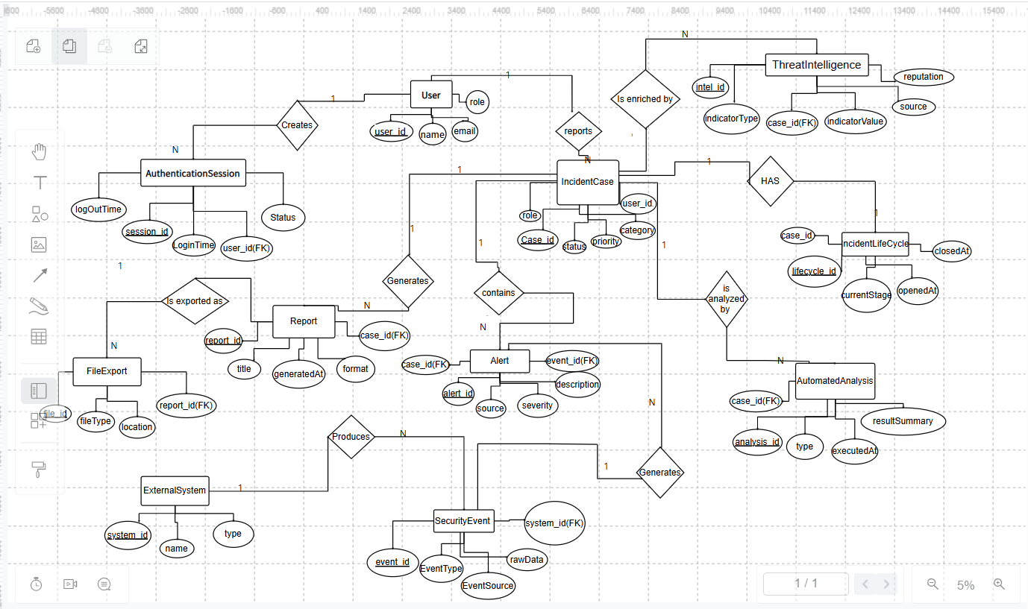
Figure 6: (ER Diagram)

Bibliography

[1] | "seim," seim, [Online]. Available: https://www.elastic.co/what-is/siem.
[2] | "soar," soar, [Online]. Available: https://www.ibm.com/think/topics/security-orchestration-automation-response.
[3] | "virustotal," virustotal, [Online]. Available: https://www.virustotal.com/gui/home/upload.
[4] | "RAG," [Online]. Available: https://aws.amazon.com/what-is/retrieval-augmented-generation/?utm_source=chatgpt.com.
[5] | "IOCs," IOCs, [Online]. Available: Fortinet, “Indicators of Compromise (IoC),” Fortinet Glossary, [Online]. Available: https://www.fortinet.com/resources/cyberglossary/indicators-of-compromise.
[6] | "SOC," [Online]. Available: 1. A. Mohsin, H. Janicke, A. Ibrahim, I. H. Sarker, and S. Camtepe, “A Unified Framework for Human AI Collaboration in Security Operations Centers with Trusted Autonomy,” arXiv preprint, May 29, 2025. [Online]. Available: https://arxiv.org/abs/2505.23397..
[7] | "Solid Architecture," [Online]. Available: https://www.researchgate.net/profile/Gideon-Areo/publication/393377303_Comparative_Analysis_of_Low-  Code_vs_Traditional_RPA_in_Pharmaceutical_Workflow_Automation/links/6867250be9b6c13c89e6836f/Comparative-Analysis-of-Low-Code-vs-Traditional-RPA-in-Pharmace.
[8] | "Alert & Unstructured," [Online]. Available: https://dl.acm.org/doi/full/10.1145/3723158.
[9] | "Dwell Time & Dependency," [Online]. Available: https://www.proquest.com/openview/1c5c2dff2aa427ec9786c380ae21b72a/1?pq-origsite=gscholar&cbl=18750&diss=y.
[10] | "GAP IN AI," [Online]. Available: https://www.mdpi.com/2078-2489/16/5/365.
[11] | "TTP," [Online]. Available: https://www.mdpi.com/2078-2489/16/5/365.
[12] | "Wazuh," Wazuh, 2025. [Online]. Available: https://wazuh.com/.
[13] | "Strangebee," Strangebee, [Online]. Available: https://strangebee.com/.
[14] | "cortex xsour," cortex xsour, [Online]. Available: https://xsoar.pan.dev/docs/reference/integrations/the-hive-project.
[15] | "langchain," langchain, [Online]. Available: https://www.langchain.com/.
[16] | "trycroma," [Online]. Available: https://www.trychroma.com/.
[17] | "fastapi," fastapi, [Online]. Available: https://fastapi.tiangolo.com/.
[18] | "html," html, [Online]. Available: https://html.com/.
[19] | G.Digital Marketplace, "Splunk Cloud G-Cloud 13 Pricing," GOV.UK, 2024. [Online]. Available: https://www.digitalmarketplace.service.gov.uk/. [Accessed: Jan. 3, 2026].
[20] | Amazon Web Services (AWS), "IBM Security QRadar SIEM Professional - SaaS Pricing," AWS Marketplace, 2025. [Online]. Available: https://aws.amazon.com/marketplace. [Accessed: Jan. 3, 2026].

